***..J ._*** . ....

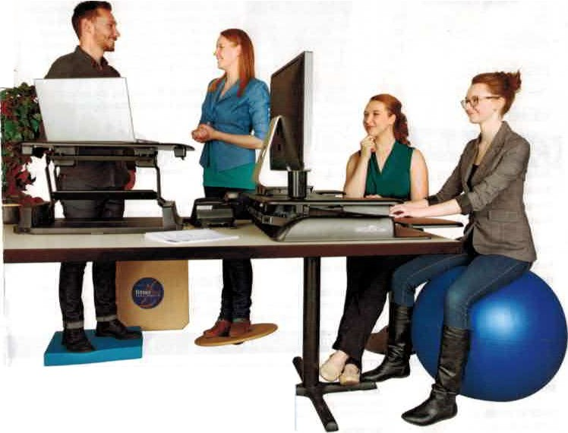

.

Se,e OOs of Pr0oucts Grder Now!

**at www.fitter 1.com 1-800-fitter i**

r•T T U! **,\T ,·t11**

f II I;*ii* I\ l'l**.1.'•**

Active Office

## $

Tralnin& & Alhletic

Injury & Preven11on

**w**

i :J lf H : **M[l'llt**

# 

F

amily filneu

**1.l l!" lot t,O!JS.**

Swopper

Th,,Sw•w•,.....illn,i p/dlaml lnnitpclal"" mcliM Ill> lhe 11"1 ill Ii,or• of

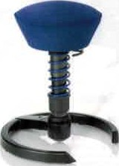

..,.,...,for. M""'

30ee Active Office Chair

ti, ,m fm"""'"'f 11o ,11,,v M/Jil()lot)D.JS ntiM.'fl•ltJ llt•ui:rt ortlUfflllUl'il I lll"llllth.t11• fh1'1't!IN'l'l\

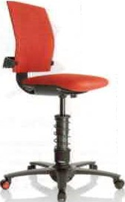

nah11a.l 11r1rl

### fulult1YV1

mr>Y1""ffh'lfltS .

iMd

### iuca

i\U(h fJIQti?Jtttmf.cbn Bii :.

.,..,,,,(11"'1on"'IJ. WI•rn,,: und

### ilovtl<lng II JD roolloll rroktltl

tt1·n1hi1'r".l"fM"oltnses,,'t"m'"1"11111. nACl,ve

Iii"!'.,..."'"""f.. n "' •)'1'1h1

. to"""'"hdgtl. ""'II'.

,,J.... k ..,rtioc,,

* p::t,bJr1! •ndVf'ft!iDI lfll"G

•"H"b"ll,I6IW1nb:klllsmu-, ,p1,., ,.i

nllluu,OOCk l""1

* UICl1li""5CNl"til.Jlioo,lid

imn,,:-: .,111

U1«trolly lhal', 1,y 11,.30•• Active Offic1 C.tmir •Oc)IIQll cm'k.::elJI "" ,1e,.;lo[,.,,lw ll• ll•,.,fli, " l"'rh

# <MXll)raClon •nd aacio• The

jo.,, Clllltle!" .. lrf1L 1,1 Ir.

1>.IIOflliJd. ll W0<1!. ,ood M *1-*

od'

• *Mtm'lb!O* llpJi AJl/:1 1...,,.,,.1

• r1,,ir•· ,,._,.,,,,

"'""'t

* LIJml•lf

SWOP SWOP SWOPlW

M,c;:rooO't, (bii>r\t, *PlllY1* bhJ!t or 11

UIOIIW< (t,lw;oJ

Ullilt""WIwl""''"tlu::J\J

### $8!1!J!.0'

$1099.95

$1199.95

30[tR

3Dll!BX

lh *wt* IMlcif (r.'llll

111., kwt Ltt,, , trlffll1•

$1495,

### tM95.95

Mitd.e *11'1* G.erwlltlj

Milt, i1) Cerm-any

# 



